

# UNIVERSITY OF PETROLEUM & ENERGY STUDIES

**Dehradun**

ACO LAB

**Name- Ritik Kumar**

**Sap Id-500097106**

**Roll No-R2142211330**

**Batch-4 (DevOps)**

**SUBMITTED TO- Dr. Hitesh Kumar Sharma**

**EXPERIMENT-1**

**Performing CRUD Operation on Containers**

**Steps to be followed:**

1. Pulling a Docker image
2. Creating a new container
3. Stopping the container
4. Listing all the containers
5. Deleting the container
6. Removing the image

# Step 1: Pulling a Docker image

* 1. Open the terminal and pull an image using the command:

## “docker pull nginx”

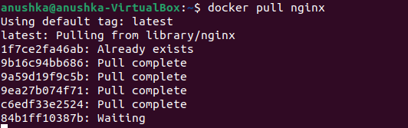

* 1. List all the docker images to check the newly pulled *nginx* image:

***“ docker images “***

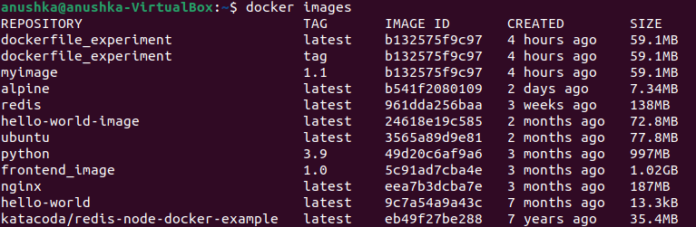

# Step 2: Creating a new container

* 1. Create a new container from the *nginx* image:

## “ docker run -dt -p 81:81 nginx “

## 

* 1. List all the running containers to check the newly created container. You can find various details like port of container, it’s time of creation and ID.

***“ docker ps ”***



# Step 3: Stopping the container

* 1. Use the following command to stop the running container. ***(***You can also us the container ID to stop the container: *“ docker stop CONTAINER_ID “****)***

## “ docker stop CONTAINER_NAME “

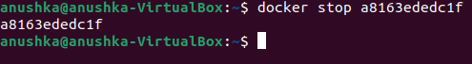

* 1. Use the following command to list all the running containers and verify if the container has stopped running:

## “ docker ps “

## 

* 1. You can start the container again and check the running containers. ***(***You can also us the container ID to start the container: *sudo docker start CONTAINER_ID****)***

## “ docker start CONTAINER_NAME “ or “ docker start CONTAINER_ID “

* 1. To start the container in interactive mode, use the –i and –t options.

“ ***docker run -it --name=Test_1 nginx “***

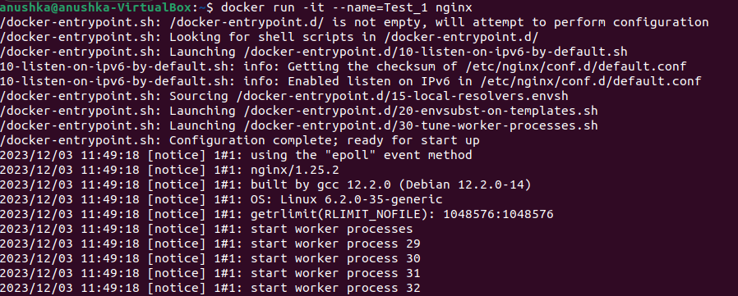

# Step 4: Listing all the containers

* 1. Use the below command to list all the containers started and the once which are stopped:

## “ docker ps -a “

## 

* 1. To list the containers by their ID, use the below command

## “ docker ps -aq “

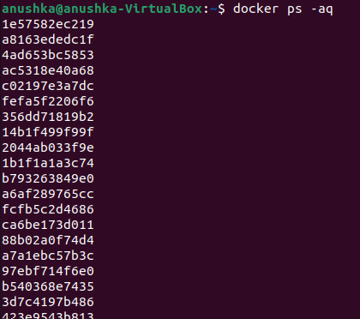

* 1. To list the total file size of each container, use the below command:

## “ docker ps -s “

## 

* 1. To list the latest created containers, use the following command:

***“ docker ps -l “***

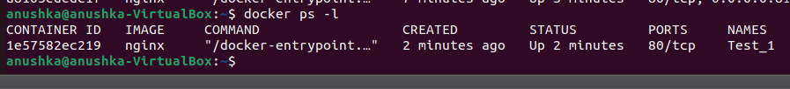

# Step 5: Deleting the container

5.1 Stop the running container and remove it using the following commands:

## “ docker stop CONTAINER_NAME “



***“ docker container rm CONTAINER_NAME “***

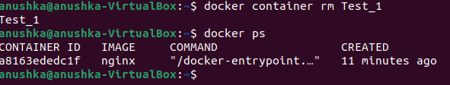

# Step 6: Removing the image

6.1 Remove the image using the command:

## “ docker image rm nginx “

